**Instruction to be followed for spring installation in eclipse**

1. Go to Help->Eclipse Marketplace, you will Prompted with a dialog box to search and get the resources.
2. Type Spring-ide in the search box and click on install once it is installed in your eclipse, the eclipse will reboot and you can the features of spring in eclipse.

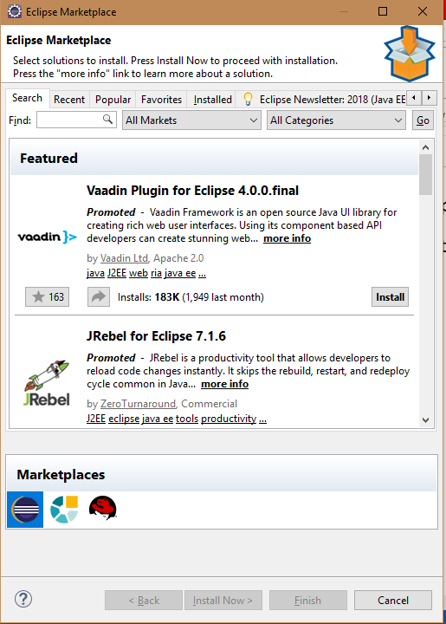

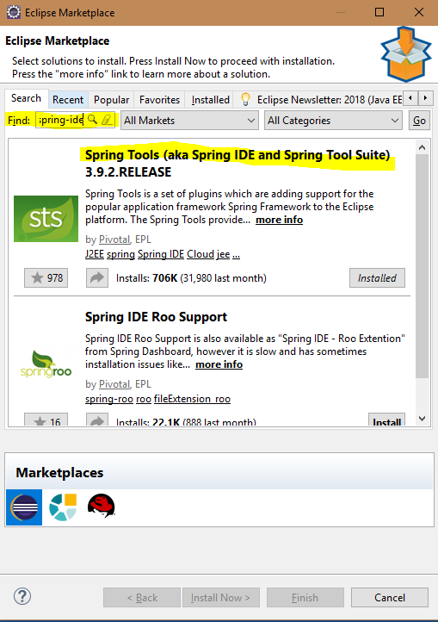

1. After Installing spring, Select File->New Maven Project to create your first maven spring project.
2. In that right click and select create new file, in the folder pane you will find the spring folder where you can create spring related files.

